Python Pillow - Blur an Image

Blurring an image can be done by reducing the level of noise in the image by applying a filter to an image. Image blurring is one of the important aspects of image processing.

The **ImageFilter class** in the Pillow library provides several standard image filters. Image filters can be applied to an image by calling the **filter() method** of Image object with required filter type as defined in the ImageFilter class.

There are various techniques used to blur images and we are going to discuss the below mentioned techniques.

* Simple blur
* Box blur
* Gaussian blur

All these three techniques are going to use ‘Image.filter()’ method for applying the filter to images.

Simple blur

It applies a blurring effect on to the image as specified through a specific kernel or a convolution matrix.

Syntax

filter(ImageFilter.BLUR)

Example

#Import required Image library

from PIL import Image, ImageFilter

#Open existing image

OriImage = Image.open('images/boy.jpg')

OriImage.show()

blurImage = OriImage.filter(ImageFilter.BLUR)

blurImage.show()

#Save blurImage

blurImage.save('images/simBlurImage.jpg')

On executing, the above example generates the two standard PNG display utility windows (in this case windows **Photos** app).

**Original image**

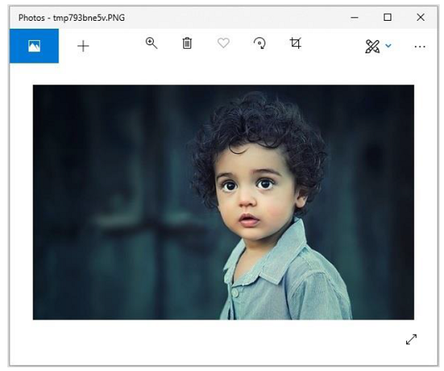

**Blurred image**

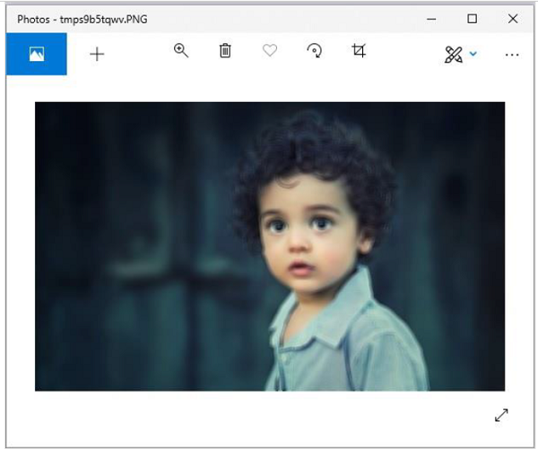

Box blur

In this filter, we use ‘radius’ as parameter. Radius is directly proportional to the blur value.

Syntax

ImageFilter.BoxBlur(radius)

Where,

* **Radius** − Size of the box in one direction.
* **Radius 0** − means no blurring & returns the same image.
* **RRadius 1**&minnus; takes 1 pixel in each direction, i.e. 9 pixels in total.

Example

#Import required Image library

from PIL import Image,

#Open existing image

OriImage = Image.open('images/boy.jpg')

OriImage.show()

#Applying BoxBlur filter

boxImage = OriImage.filter(ImageFilter.BoxBlur(5))

boxImage.show()

#Save Boxblur image

boxImage.save('images/boxblur.jpg')

Output

On executing, the above example generates the two standard PNG display utility windows (in this case windows Photos app).

**Original image**

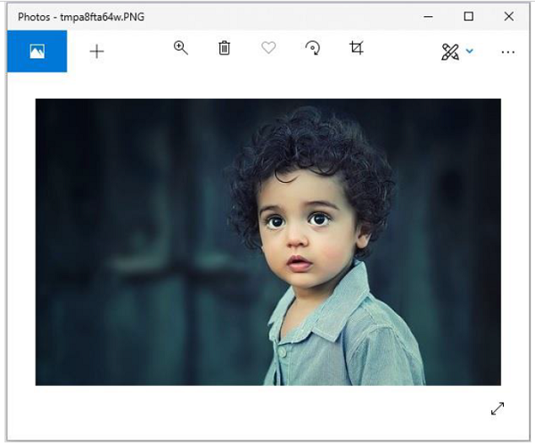

**Blurred image**

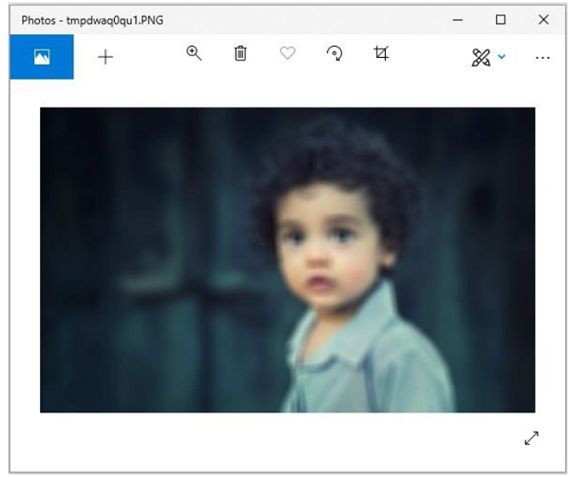

Gaussian Blur

This filter also uses parameter radius and does the same work as box blur with some algorithmic changes. In short, changing the radius value, will generate different intensity of ‘Gaussianblur’ images.

Syntax

ImageFilter.GaussianBlur(radius=2)

Where,

* Radius – Blur radius

Example

#Import required Image library

from PIL import Image, ImageFilter

#Open existing image

OriImage = Image.open('images/boy.jpg')

OriImage.show()

#Applying GaussianBlur filter

gaussImage = OriImage.filter(ImageFilter.GaussianBlur(5))

gaussImage.show()

#Save Gaussian Blur Image

gaussImage.save('images/gaussian_blur.jpg')

Output

On executing, the above example generates the two standard PNG display utility windows (in this case windows **Photos** app).

**Original image**

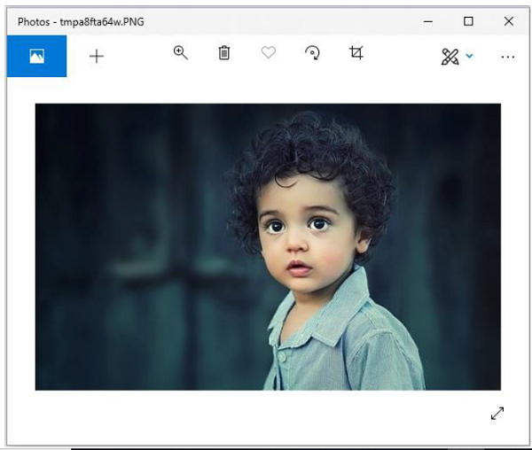

**Blurred image**

